
COMPLAINTS PROCEDURE

Introduction

The purpose of the policy is to ensure that all patients (or their representatives) who have the cause to complain about their care or treatment can have freely available access to the process and can expect a truthful, full and complete response and an apology where appropriate. Complainants have the right not to be discriminated against as the result of making a complaint and to have the outcome fully explained to them. The process adopted in the practice is fully compliant with the relevant NHS Regulations (2009) and guidance available from defence organisations, doctors` representative bodies and the Care Quality Commission. Everyone in the practice is expected to be aware of the process and to remember that everything they do and say may present a poor impression of the practice and may prompt a complaint or even legal action.

The general principle of the practice in respect of all complaints will be to regard it first and foremost as a learning process, however in appropriate cases and after full and proper investigation the issue may form the basis of a separate disciplinary action. In the case of any complaint with implications for professional negligence or legal action, the appropriate defence organisation must be informed immediately.

Procedure

Availability of information
The practice will ensure that there are notices advising on the complaints process conspicuously displayed in all reception/waiting areas and that leaflets containing sufficient details for anyone to make a complaint are available without the need to ask. The practice website and any other public material such as the Practice Leaflet will similarly provide this information and also signpost the complainant to the help available through the NHS Complaints Advisory Service.

Who can a formal complaint be made to?
ONLY TO - either the practice -OR - NHS England

In the event of anyone not wishing to complain to the practice they should be directed to make their complaint to NHSE at:
By telephone: 03003 11 22 33
By email: england.contactus@nhs.net
By post: NHS England, PO Box 16738, Redditch, B97 9PT
In those cases where the complaint is made to NHS England, the practice will comply with all appropriate requests for information and co-operate fully in assisting them to investigate and respond to the complaint.

Who can make a complaint?
A complaint can be made by or, with consent, on behalf of a patient (i.e. as a representative); a former patient, who is receiving or has received treatment at the Practice; or someone who may be affected by any decision, act or omission of the practice.
A Representative may also be
- by either parent or, in the absence of both parents, the guardian or other adult who has care of the child; by a person duly authorised by a local authority to whose care the child has been committed under the provisions of the Children Act 1989; or by a person duly authorised by a voluntary organisation by which the child is being accommodated
- someone acting on behalf of a patient/ former patient who lacks capacity under the Mental Capacity Act 2005 (i.e. who has Power of Attorney etc.) or physical capacity to make a complaint and they are acting in the interests of their welfare
- someone acting for the relatives of a deceased patient/former patient
In all cases where a representative makes a complaint in the absence of patient consent, the practice will consider whether they are acting in the best interests of the patient and, in the case of a child, whether there are reasonable grounds for the child not making the complaint on their own behalf. In the event a complaint from a representative is not accepted, the grounds upon which this decision was based must be advised to them in writing.

Who is responsible at the practice for dealing with complaints?
The practice "Responsible Person" is Dr Alvin Sornum. They are charged with ensuring complaints are handled in accordance with the regulations, that lessons learned are fully implemented, and that no Complainant is discriminated against for making a complaint. This person should be a practice Partner (BMA Guidance and Primary Care contracts)

The practice "Complaints Manager" is the Practice Manager Carole Jones with delegated responsibility for managing complaints and ensuring adequate investigations are carried out. (N.B. they can be the same person but the Responsible Person must be a Partner, who may then delegate the complaints management role to someone else - omit or amend as per practice choice)

Time limits for making complaints
The period for making a complaint is normally:
(a) 12 months from the date on which the event which is the subject of the complaint occurred; or
(b) 12 months from the date on which the event which is the subject of the complaint comes to the complainant's notice.

The practice has discretion to extend these limits if there is good reason to do so and it is still possible to carry out a proper investigation. The collection or recollection of evidence, clinical guidelines or other resources relating to the time when the complaint event arose may also be difficult to establish or obtain. These factors may be considered as suitable reasons for declining a time limit extension, however that decision should be able to stand up to scrutiny.

Action upon receipt of a complaint

A) Verbal Complaints: It is always better to try and deal with the complaint at the earliest opportunity and often it can be concluded at that point. At times and after investigation an explanation and apology by staff at the time may be all that is required.
A verbal complaint need not be responded to in writing for the purposes of the Regulations if it is dealt with to the satisfaction of the complainant by the end of the next working day, neither does it need to be included in the annual Complaints Return. The practice will however record them for the purposes of monitoring trends or for Clinical Governance and that record will be kept and monitored by the data protection lead. Verbal complaints not formally recorded will be discussed when trends or issues need to be addressed and at least annually, with minutes of those discussions kept.

If resolution is not possible, the Complaints Manager will set down the details of the verbal complaint in writing and provide a copy to the complainant within three working days. This ensures that each side is well aware of the issues for resolution. The process followed will be the same as for written complaints.

B) Written Complaints: On receipt, an acknowledgement will be sent within three working days which offers the opportunity for a discussion (face-to-face or by telephone) on the matter. This is the opportunity to gain an indication of the outcome the complainant expects and also for the details of the complaint to be clarified. In the event that this is not practical or appropriate, the initial response should give some indication of the anticipated timescale for investigations to be concluded and an indication of when the outcome can be expected.

It may be that other bodies (e.g. secondary care/ Community Services) will need to be contacted to provide evidence. If that is the case, then a patient consent form will need to be obtained at the start of the process and a pro-forma consent form included with the initial acknowledgement for return.

If it is not possible to conclude any investigations within the advised timescale, then the complainant must be updated with progress and revised time scales on a regular basis. In most cases these should be completed within six months unless all parties agree to an extension.

The Investigation
The practice will ensure that the complaint is investigated in a manner that is appropriate to resolve it speedily and effectively and proportionate to the degree of seriousness that is involved.
The investigations will be recorded in a complaints file created specifically for each incident and where appropriate should include evidence collected as individual explanations or accounts taken in writing.

Final Response
This will be provided to the complainant in writing (or email by mutual consent) and the letter will be signed by the Responsible Person or Complaints Manager under delegated authority. The letter will be on headed notepaper and include:
- An apology if appropriate (The Compensation Act 2006, Section 2 expressly allows an apology to be made without any admission of negligence or breach of a statutory duty)
- A clear statement of the issues, details of the investigations and the findings, and clear evidence-based reasons for decisions if appropriate
- Where errors have occurred, explain these fully and state what has been or will be done to put these right or prevent repetition. Clinical matters must be explained in accessible language.
- A clear statement that the response is the final one and the practice is satisfied it has done all it can to resolve the matter at local level
- A statement of the right, if they are not satisfied with the response, to refer the complaint to the Parliamentary and Health Service Ombudsman, Millbank Tower, Millbank, London, SW1P 4QP or visit the 'Making a complaint page' at http://www.ombudsman.org.uk/make-a-complaint (to complain online or download a paper form). Alternatively the complainant may call the PHSO Customer Helpline on 0345 015 4033 from 8:30am to 5:30pm, Monday to Friday or send a text to their 'call back' service: 07624 813 005

The final letter should not include:
- Any discussion or offer of compensation without the express involvement and agreement of the relevant defence organisation(s)
- Detailed or complex discussions of medical issues with the patient’s representative unless the patient has given informed consent for this to be done where appropriate.

Annual Review of Complaints
The practice will produce an annual complaints report to be sent to the local Commissioning Body (NHSE) and will form part of the Freedom of Information Act Publication Scheme.

The report will include:
- Statistics on the number of complaints received
- The number considered to have been upheld
- Known referrals to the Ombudsman
- A summary of the issues giving rise to the complaints
- Learning points that came out of the complaints and the changes to procedure, policies or care which have resulted

Care must be taken to ensure that the report does not inadvertently disclose any confidential data or lead to the identity of any person becoming known.

Confidentiality
All complaints must be treated in the strictest confidence and the practice must ensure that the patient etc. is made aware of any confidential information to be disclosed to a third party (e.g. NHSE).
The practice must keep a record of all complaints and copies of all correspondence relating to complaints, but such records must be kept separate from patients' medical records and no reference which might disclose the fact a complaint has been made should be included on the computerised clinical record system.

Unreasonable or Vexatious Complaints
Where a complainant becomes unreasonable or excessively rude or aggressive in their promotion of the complaint, some or all of the following formal provisions will apply and must be communicated to the patient by the Responsible Person in writing:

- The complaint will be managed by one named individual at senior level who will be the only contact for the patient
- Contact will be limited to one method only (e.g. in writing)
- Place a time limit on each contact
- The number of contacts in a time period will be restricted
- A witness will be present for all contacts
- Repeated complaints about the same issue will be refused unless additional material is being brought forward
- Only acknowledge correspondence regarding a closed matter, not respond to it
- Set behaviour standards
- Return irrelevant documentation
- Detailed records will be kept of each encounter

Complaints involving Locums
It is important that all complaints made to the practice regarding or involving a locum (Doctor, Nurse or any other temporary staff) are dealt with by the practice and not passed off to a Locum Agency or the individual locum to investigate and respond. The responsibility for handling and investigating all complaints rests with the Practice.

Locum staff should however be involved at an early stage and be advised of the complaint in order that they can provide any explanations, preferably in writing. It would not be usually appropriate for any opinions to be expressed by the Practice on Locum staff. Providing their factual account along with any factual account from the practice is the best way to proceed.

The practice will ensure that on engaging any Locum, the Locum Agreement will include an assurance that they will participate in any complaint investigation where they are involved or can provide any material evidence. The practice will ensure that there is no discrepancy in the way it investigates or handles complaints between any Locum staff and either practice Partners, salaried staff, students or trainees or any other employees.

"Informal complaints"
The collection of data about informal complaints is a good tool for identifying trends for low-level dissatisfaction with services or the way they are offered to patients.
Staff are encouraged to raise these issues at practice meetings. In addition, patients are encouraged to raise any dissatisfaction with staff and/or services through feedback forms located in reception, through the practice website and via text messaging response opportunities.

References
Local Authority Social Services & National Health Service Complaints (England) Regulations 2009 - S.I. 209, No.309
NHS Complaints Procedure (England only): Guidance for Primary Care, BMA August 2015
NHS Choices
http://www.nhs.uk/chq/pages/1084.aspx?categoryid=68
Medico-legal guide to the NHS Complaints Procedure, M.D.U.
https://www.themdu.com/guidance-and-advice/topics/complaints
A Guide to effective complaints Resolution, M.P.S 2016
http://www.cddlmc.org.uk/wp-content/uploads/2011/09/MPS-NHS-Complaints-Guidance.pdf
NHS England Complaints policy;
https://www.england.nhs.uk/contact-us/complaint/
BMA guidance for Primary Care –
https://www.bma.org.uk/advice/employment/raising-concerns/compaints-in-primary-care
January 2019 – 3rd Report on the effect of the NHS Constitution
https://assets.publishing.service.gov.uk/government/uploads/system/uploads/attachment_data/file/770525/Statutory_report_on_NHS_Constitution_January_for_2019.pdf
Complaints Handling Flowchart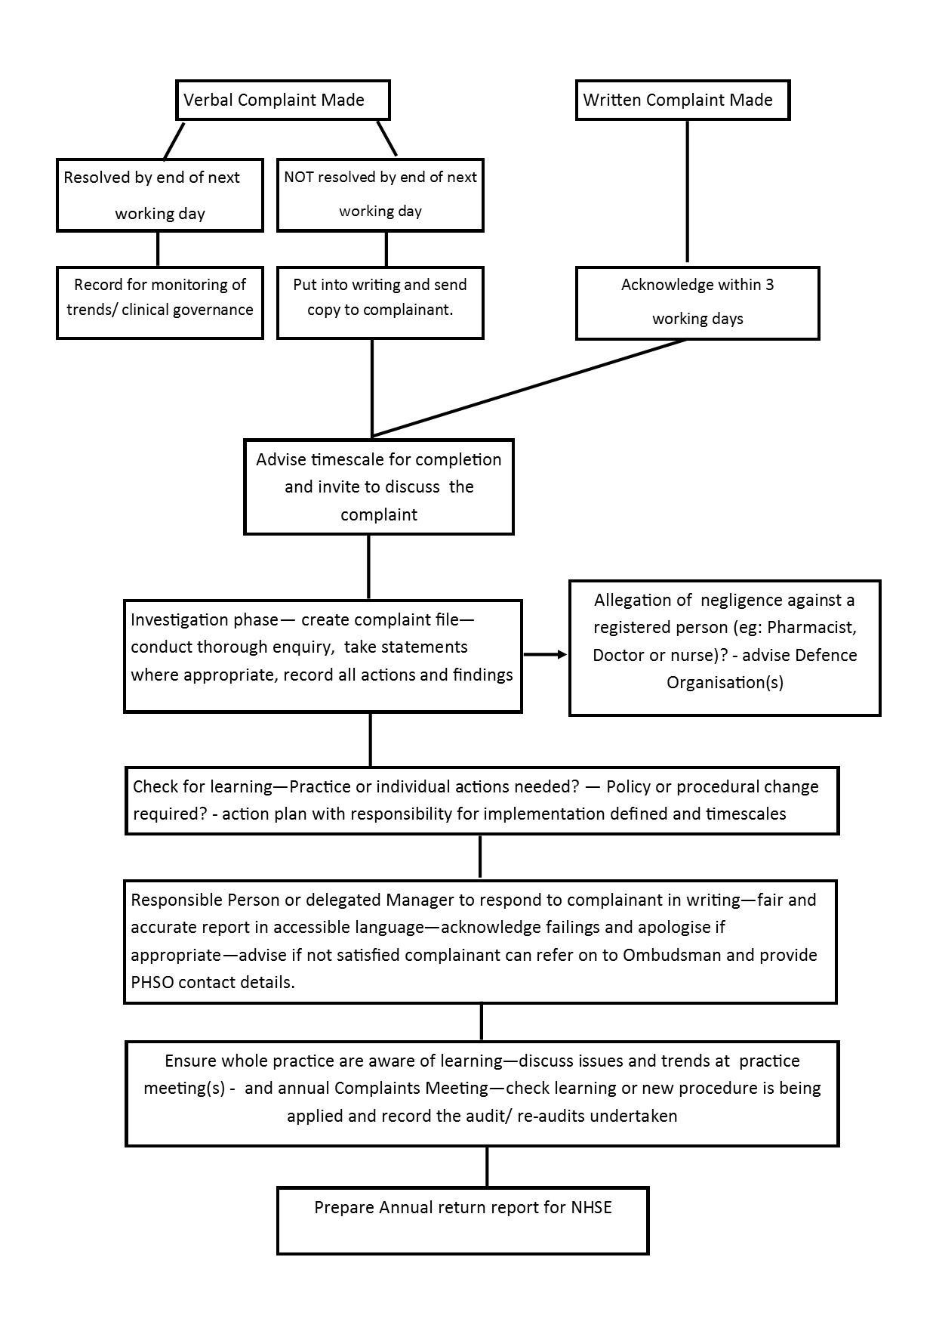

Document Detail
Document Type |  | Word
Document Name |  | Complaints Policy
Version |  | 6.3
Effective From |  | February 2024
Review Date |  | February 2026
Owner |  | Carole Jones
Prepared by |  | Carole Jones
Date | Change History |  | Approved by
May 2022 | Updated |  | SD
Feb 2024 | New Template. Wording changed and amended contacts |  | CJ

